Jewish Poetry Salon
Featuring [insert reader names here]

Join us [event date] for an evening of wide-ranging, powerful poetry that demonstrates the diversity and depth of the Jewish poetry written today. We welcome poetry lovers of all traditions.

Our featured readers will be followed/preceded by an open mic. [cut this is you prefer only featured readers]

[Perhaps a bit about you, your organization, congregation, reading series, etc. and why you’re choosing to host Jewish literary event]

[Brief reader bios]

DATE & TIME:
ADDRESS:
QUESTIONS? Contact [your contact info]

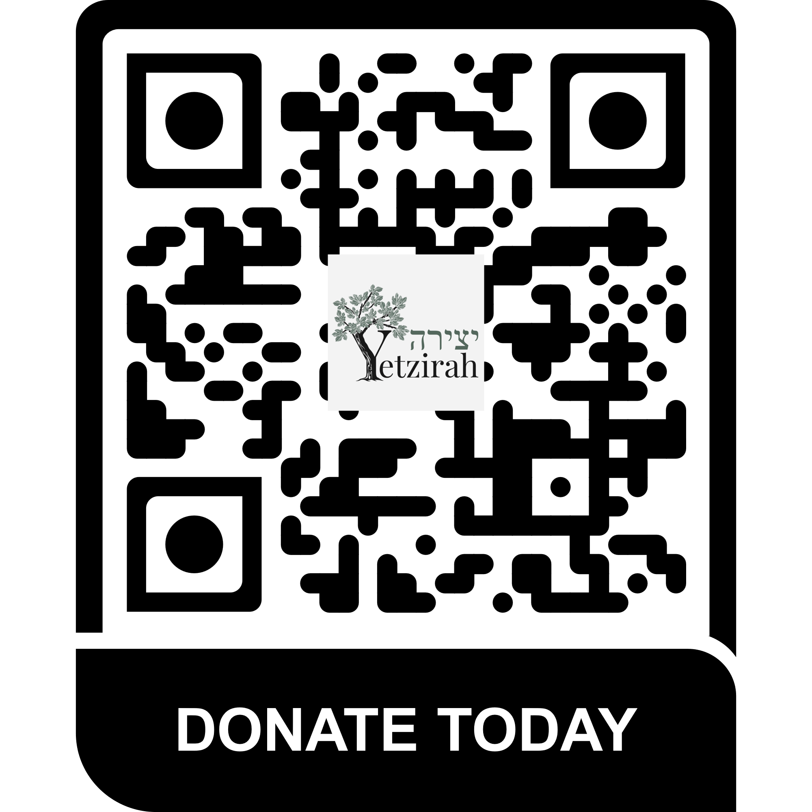
This event is inspired by Yetzirah, the first national literary organization dedicated to fostering and supporting a community space for Jewish poets, nourishing writers and readers of Jewish poetry now and for generations to come.

Donations to Yetzirah are encouraged and greatly appreciated.

Yetzirah is recognized as a 501(c)(3) nonprofit organization under the Internal Revenue code. Gifts made to Yetzirah are tax-deductible to the fullest extent of the law.

