Yetzirah Poetry Watch Party

Yetzirah is the first national literary organization dedicated to fostering and supporting a community space for Jewish poets, nourishing writers and readers of Jewish poetry now and for generations to come.

[Name of your organization/series] is excited to host a viewing party of Yetzirah’s recorded/live reading on [Date & Time]. The readers will be [copy and paste names from those in your selected reading].

After the reading, we look forward to hosting a discussion/open mic inspired by what we’ve heard.

Yetzirah’s annual reading series celebrates the publication of recently released collections and anthologies, promoting the work of both emerging and established Jewish poets. Each reading takes its theme from the Jewish calendar, with topics including self-reflection, wildness, and liberation.

[Perhaps a bit about you, your organization, congregation, reading series, etc. and why you’re choosing to host a Yetzirah event]

We hope you’ll join us for an evening of wide-ranging, powerful poetry that demonstrates the diversity and depth of the Jewish poetry written today.

DATE & TIME:

ADDRESS:

QUESTIONS? Contact [your contact info]

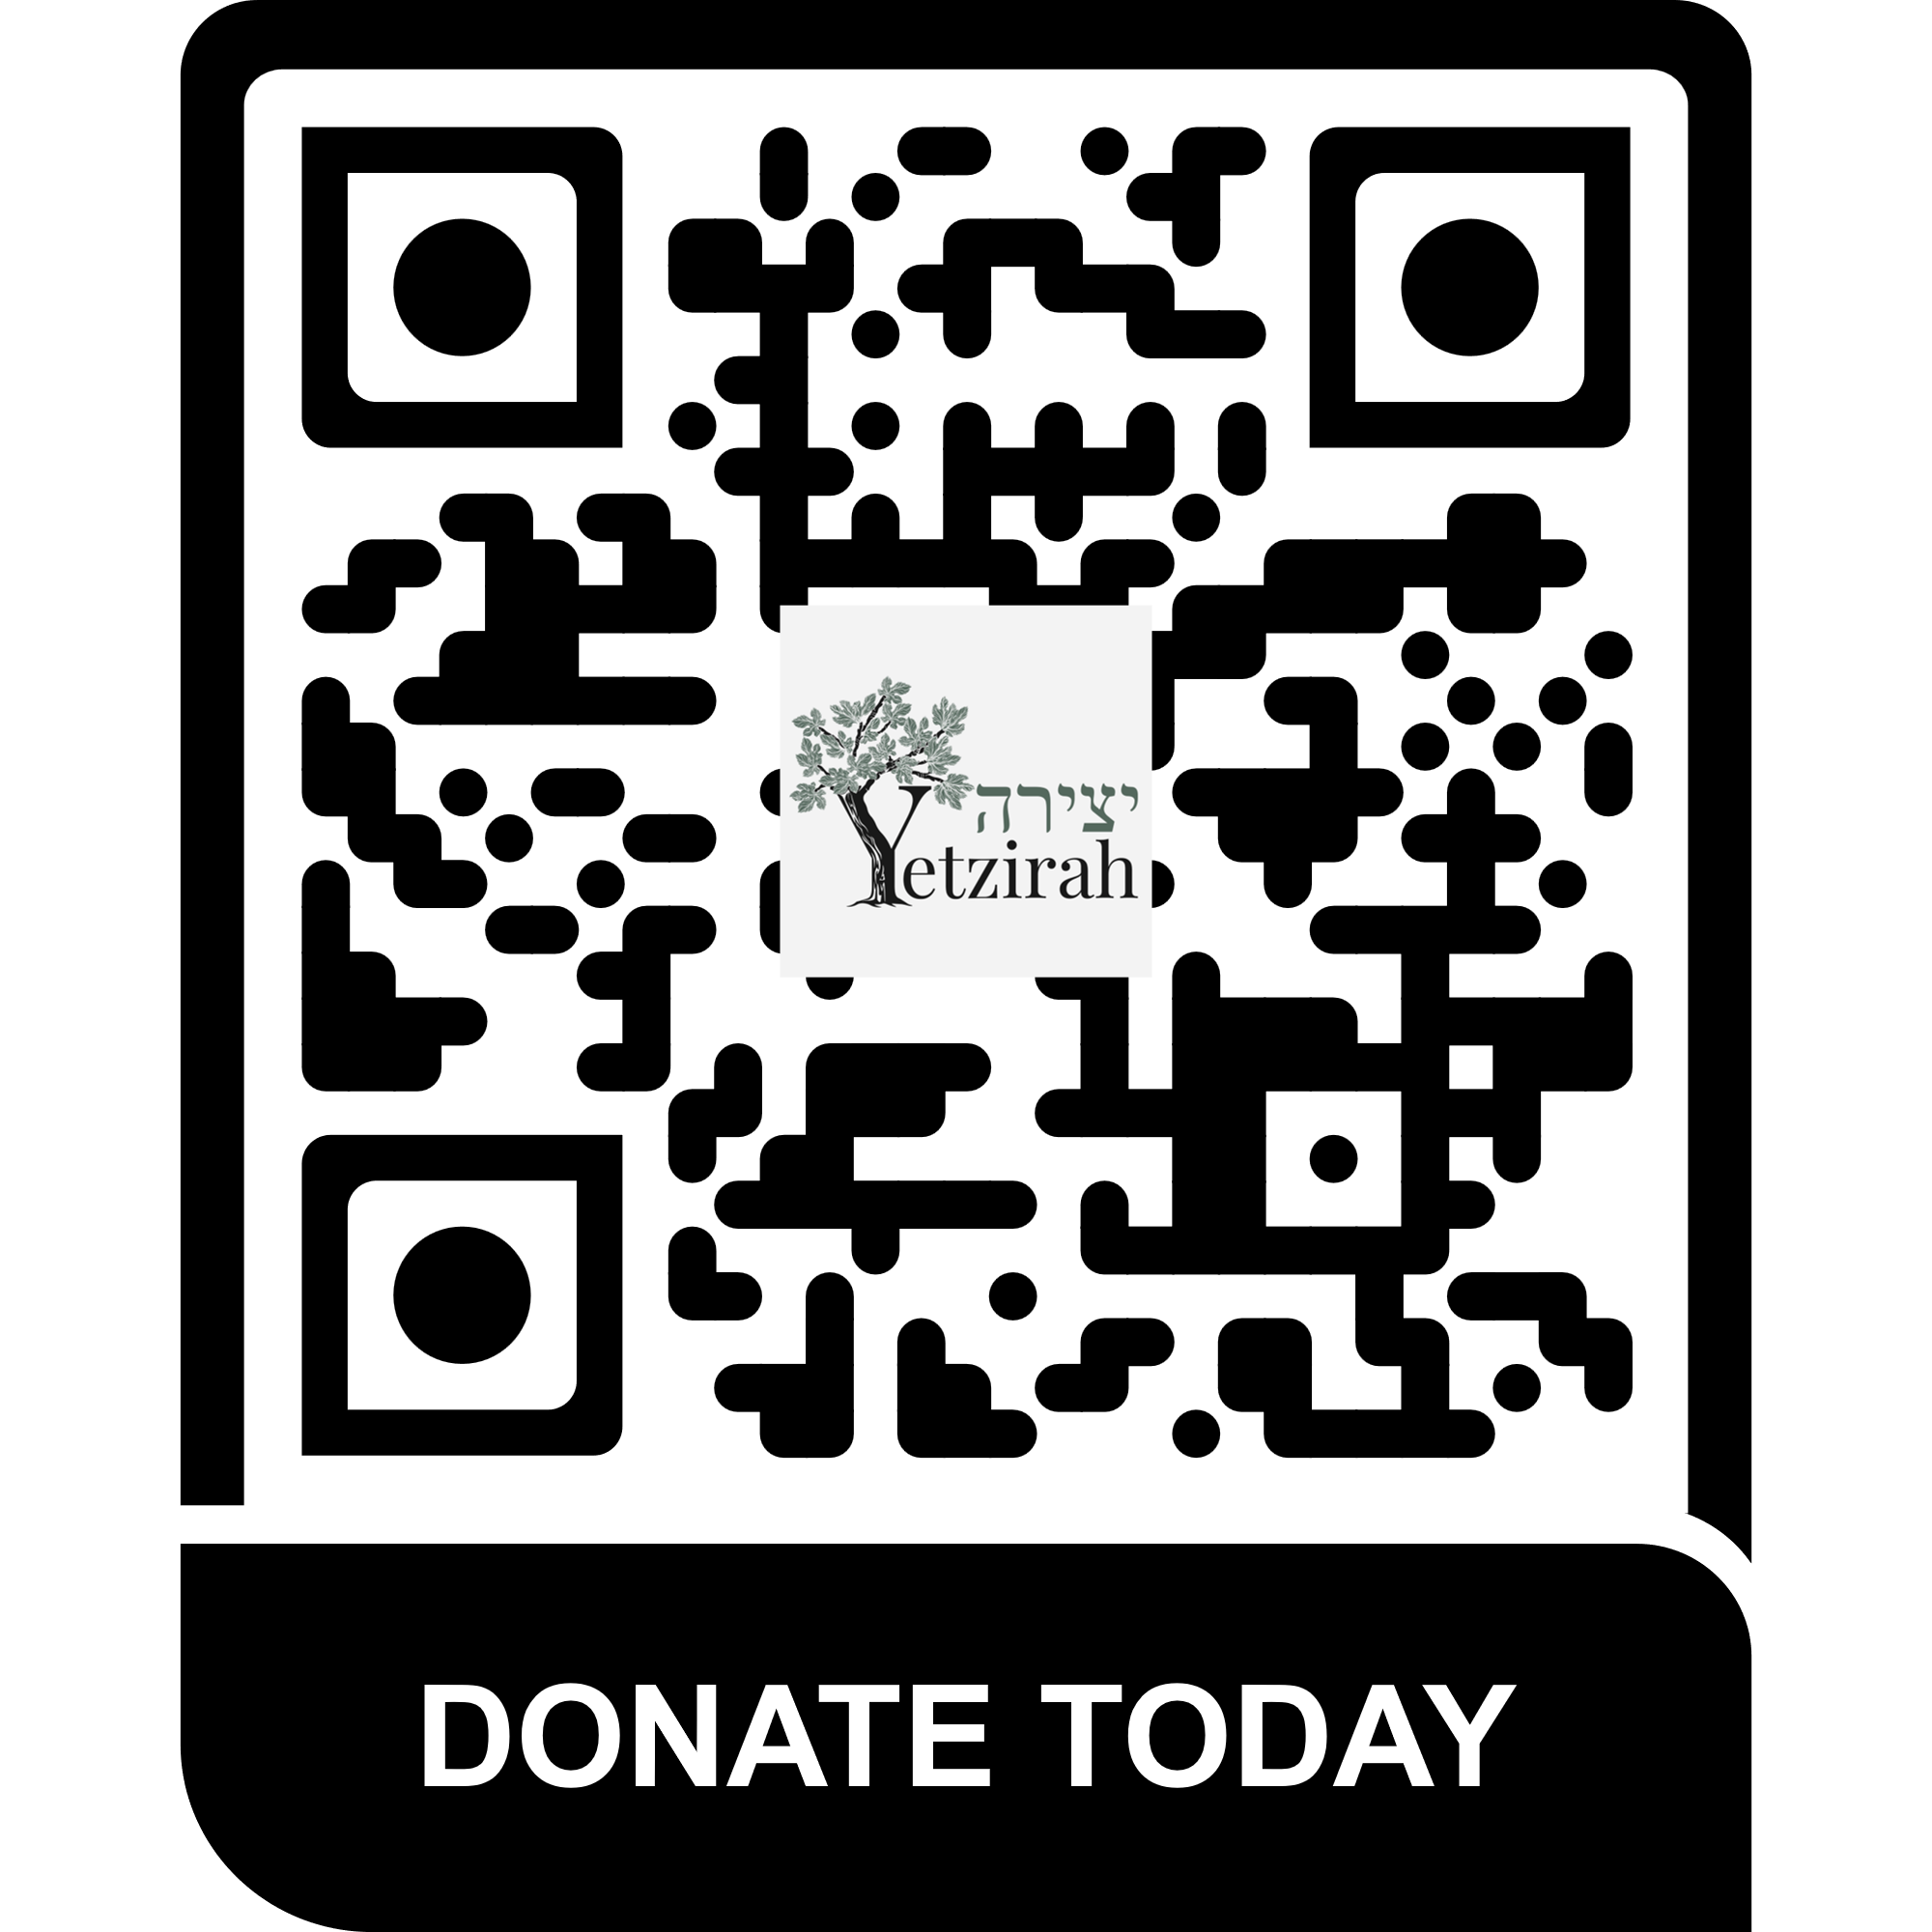
This event is inspired by Yetzirah, the first national literary organization dedicated to fostering and supporting a community space for Jewish poets, nourishing writers and readers of Jewish poetry now and for generations to come.

Donations to Yetzirah are encouraged and greatly appreciated.

Yetzirah is recognized as a 501(c)(3) nonprofit organization under the Internal Revenue code. Gifts made to Yetzirah are tax-deductible to the fullest extent of the law.

